**SPRINT – 3**

|  |  |
| --- | --- |
| Date | 19 September 2022 |
| Team ID | PNT2022TMID54398 |
| Project Name | Project - Smart Fashion Recommender Application |
| Member Name | Prabhavathy.S  Karthikeyan.T  Divyesh.G  Murugeshwaran.V |

INTEGRATING CHATBOT WITH HTML PAGE (SOURCE CODE):

<a href="/logout">Sign Out</a>

</div>

</div>

{% endif %}

<div id="kart">

<a class="link" href="/cart">

<img src={{url_for('static', filename='images/shoppingCart.png')}} id="cartIcon" />

CART {{noOfItems}}

</a>

</div>

</div>

<div id="cartItems">

<h2>Shopping Cart</h2>

<div id="tableItems">

{% for row in products %}

<div>

<hr id="seperator">

<div id="itemImage">

<img src={{url_for('static', filename='uploads/'+row[3])}} id="image"/>

</div>

<div id="itemName">

<span id="itemNameTag">{{row[1]}}</span><br>

In stock<br>

<a href="/removeFromCart?productId={{row[0]}}">Remove</a>

</div>

<div id="itemPrice">

${{row[2]}}

</div>

</div>

{% endfor %}

<hr id="seperator">

<div id="total">

<span id="subtotal">Subtotal</span> : Rs:{{totalPrice}}

</div>

</div>

</div>

<a href=>Proceed to buy </a>

</body>

</html>

INTEGRATING CHATBOT WITH HTML PAGE:

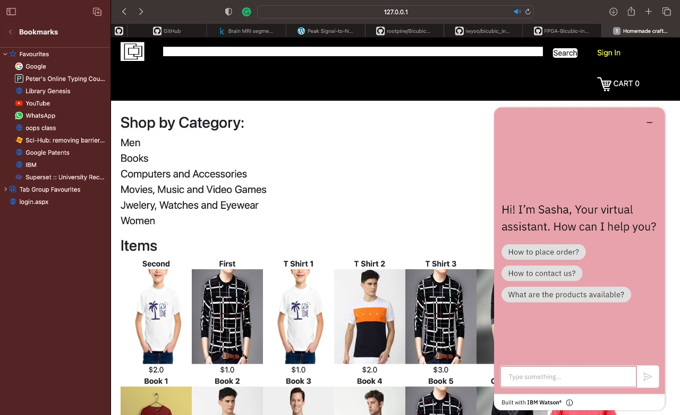

DOCKER PUSH:

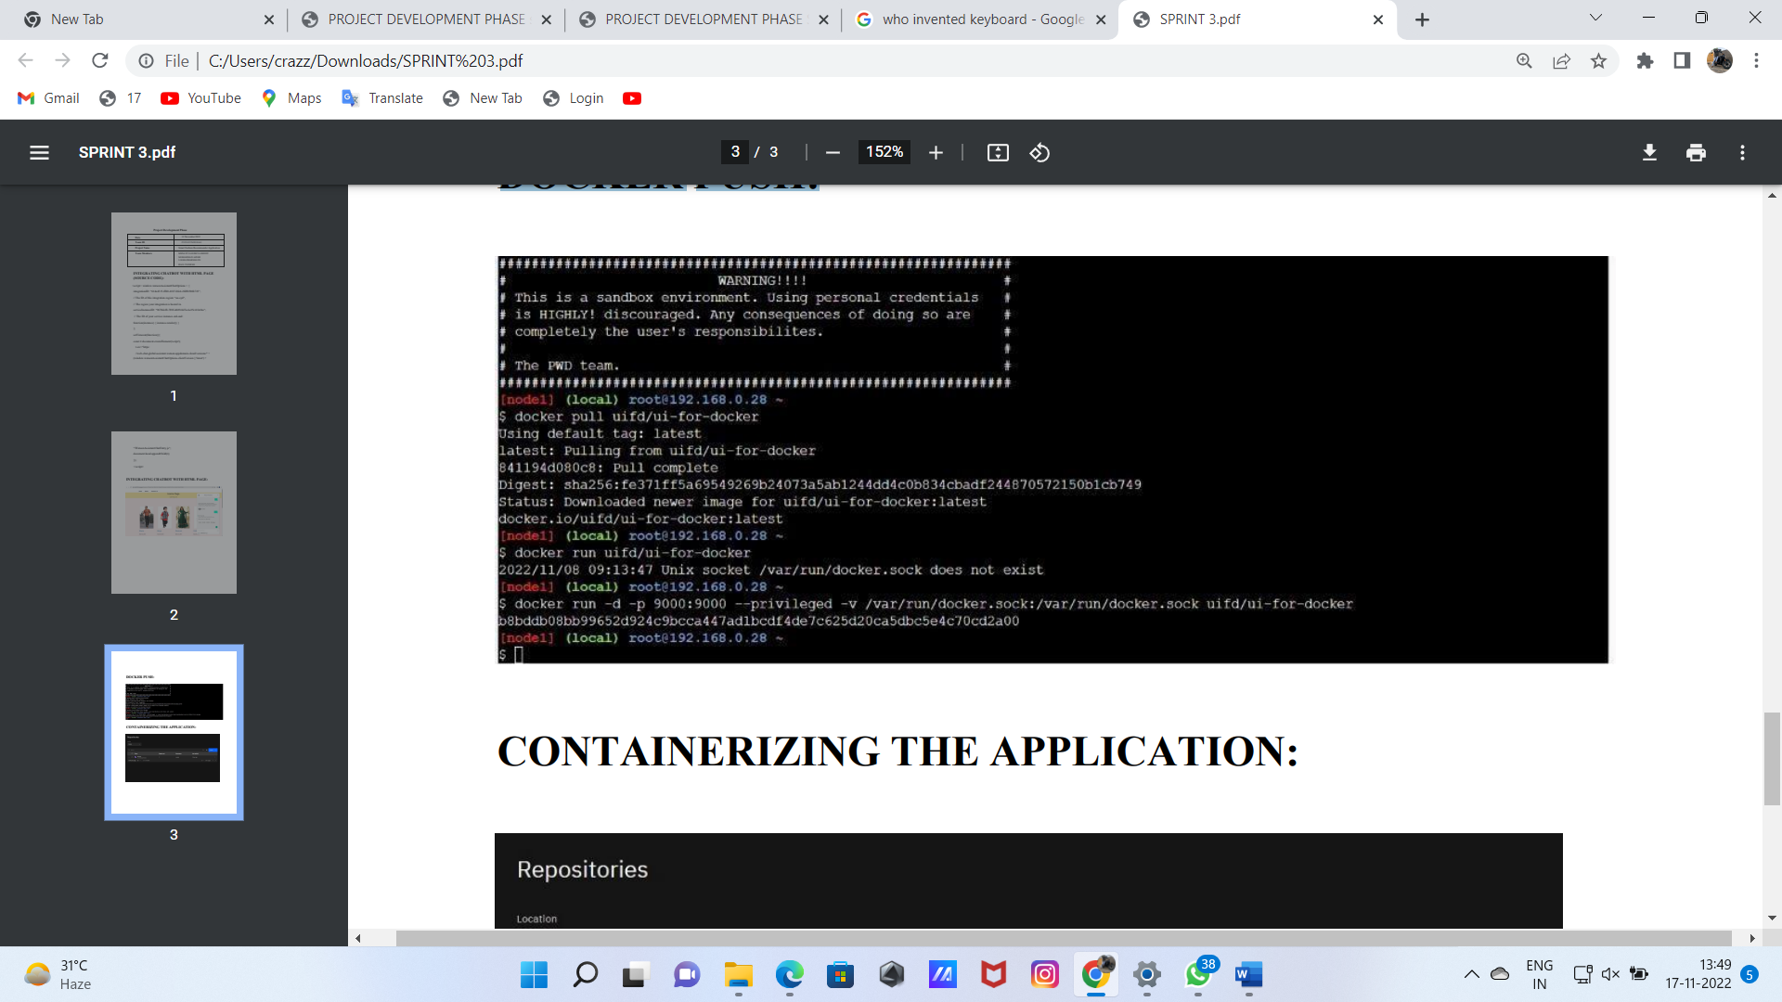

CONTAINERIZING THE APPLICATION:

